**Mad codes**

**Alert dialog box :**

**Mainactivity.kt:**

**package** com.example.alertdialogbox  
  
**import** android.content.DialogInterface  
**import** androidx.appcompat.app.AppCompatActivity  
**import** android.os.Bundle  
**import** android.widget.Button  
**import** androidx.appcompat.app.AlertDialog  
  
**class** MainActivity : AppCompatActivity() {  
 **override fun** onCreate(savedInstanceState: Bundle?) {  
 **super**.onCreate(savedInstanceState)  
 setContentView(R.layout.activity_main)  
  
 **var** btn:Button= findViewById(R.id.button);  
 btn.setOnClickListener **{  
 val** dialogBuilder=AlertDialog.Builder(**this**);  
 dialogBuilder.setTitle(**"AlertDialogExample"**)  
 dialogBuilder.setMessage(**"Do you want to close it? "**)  
 dialogBuilder.setPositiveButton(**"OK"**,DialogInterface.OnClickListener**{** dialog, id **->** finish();  
 **}**)  
 dialogBuilder.setNegativeButton(**"CANCEL"**,DialogInterface.OnClickListener**{** dialog, id**->** dialog.cancel();  
 **}**)  
 dialogBuilder.show();  
 **}** }  
}

**mainactivity.xml:**

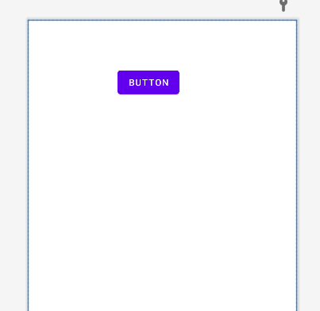

**Autocomplete text view and multiautocomplete text view**

**Mainactivity.kt :**

**package** com.example.a2_autocompletetextview  
  
**import** androidx.appcompat.app.AppCompatActivity  
**import** android.os.Bundle  
**import** android.widget.ArrayAdapter  
**import** android.widget.AutoCompleteTextView  
**import** android.widget.MultiAutoCompleteTextView  
  
**class** MainActivity : AppCompatActivity() {  
 **val** state = arrayOf(**"Gujarat"**, **"Goa"**, **"MP"**, **"Maharashtra"**, **"UP"**)  
  
 **override fun** onCreate(savedInstanceState: Bundle?) {  
 **super**.onCreate(savedInstanceState)  
 setContentView(R.layout.activity_main)  
  
 **var** autoTextView:AutoCompleteTextView=findViewById(R.id.autoCompleteTextView);  
 **val** adapter: ArrayAdapter<String> = ArrayAdapter<String>(**this**,android.R.layout.select_dialog_item, state)  
 autoTextView.setAdapter(adapter)  
 autoTextView.threshold = 1  
  
  
 **var** mautoTextView: MultiAutoCompleteTextView = findViewById(R.id.multiAutoCompleteTextView);  
 mautoTextView.setAdapter(adapter);  
 mautoTextView.setTokenizer(MultiAutoCompleteTextView.CommaTokenizer());  
 mautoTextView.threshold = 1  
 }  
}

**mainactiivty.xml:**

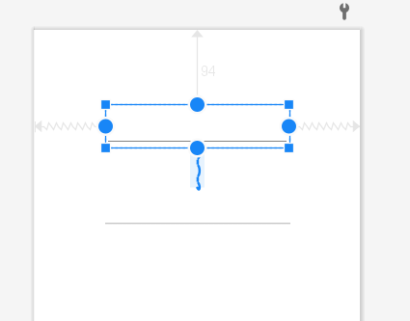

**Datepicker :**

**Mainactivity.kt:**

**package** com.example.datetimepickerall  
  
**import** androidx.appcompat.app.AppCompatActivity  
**import** android.os.Bundle  
**import** android.widget.DatePicker  
**import** android.widget.TimePicker  
**import** android.widget.Toast  
  
**class** MainActivity : AppCompatActivity() {  
 **override fun** onCreate(savedInstanceState: Bundle?) {  
 **super**.onCreate(savedInstanceState)  
 setContentView(R.layout.activity_main)  
  
 **var** dp:DatePicker=findViewById(R.id.datepic1)  
 **var** tp:TimePicker=findViewById(R.id.time1);  
 dp.setOnDateChangedListener **{** picker, Year, Month, Day **->  
  
 var** msg:String = Day.toString() + **"/"** + (Month + 1).toString() + **"/"** + Year.toString()  
 Toast.makeText(**this**,msg,Toast.LENGTH_LONG).show()  
  
 **}** tp.setOnTimeChangedListener **{** picker, HR, MUN **->  
 var** t: String = HR.toString() + **" : "** + MUN.toString()  
 Toast.makeText(**this**,t,Toast.LENGTH_LONG).show()  
  
 **}** }  
}

**mainactivity.xml**

**code :**

*<?***xml version="1.0" encoding="utf-8"***?>*<**androidx.constraintlayout.widget.ConstraintLayout xmlns:android="http://schemas.android.com/apk/res/android"  
 xmlns:app="http://schemas.android.com/apk/res-auto"  
 xmlns:tools="http://schemas.android.com/tools"  
 android:layout_width="match_parent"  
 android:layout_height="match_parent"  
 tools:context=".MainActivity"**>  
  
 <**DatePicker  
 android:id="@+id/datepic1"  
 android:layout_width="0dp"  
 android:layout_height="0dp"  
 android:layout_marginStart="27dp"  
 android:layout_marginTop="4dp"  
 android:layout_marginEnd="27dp"  
 app:layout_constraintBottom_toTopOf="@+id/time1"  
 app:layout_constraintEnd_toEndOf="parent"  
 app:layout_constraintHorizontal_bias="0.0"  
 app:layout_constraintStart_toStartOf="parent"  
 app:layout_constraintTop_toTopOf="parent"** />  
  
 <**TimePicker  
 android:id="@+id/time1"  
 android:layout_width="387dp"  
 android:layout_height="336dp"  
 android:layout_marginStart="11dp"  
 android:layout_marginEnd="11dp"  
 android:layout_marginBottom="6dp"  
 app:layout_constraintBottom_toBottomOf="parent"  
 app:layout_constraintEnd_toEndOf="parent"  
 app:layout_constraintHorizontal_bias="0.0"  
 app:layout_constraintStart_toStartOf="parent"  
 app:layout_constraintTop_toBottomOf="@+id/datepic1"** />  
  
  
</**androidx.constraintlayout.widget.ConstraintLayout**>

**Design:**

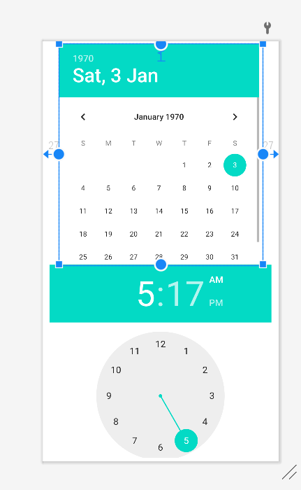

**Database connection**:

Mainactivity.kt :

**package** com.example.dbconninclassdemo  
  
**import** android.content.ContentValues  
**import** android.database.Cursor  
**import** android.database.sqlite.SQLiteDatabase  
**import** androidx.appcompat.app.AppCompatActivity  
**import** android.os.Bundle  
**import** android.widget.*  
  
**class** MainActivity : AppCompatActivity() {  
 **override fun** onCreate(savedInstanceState: Bundle?) {  
 **super**.onCreate(savedInstanceState)  
 setContentView(R.layout.*activity_main*)  
 **var** btnsave:Button=findViewById(R.id.*save*)  
 **var** btnfirst:Button=findViewById(R.id.*first*)  
 **var** btnlast:Button=findViewById(R.id.*last*)  
 **var** btnnext:Button=findViewById(R.id.*next*)  
 **var** btnpre:Button=findViewById(R.id.*pre*)  
 **var** btnupdate:Button=findViewById(R.id.*update1*)  
 **var** btndelete:Button=findViewById(R.id.*delete1*)  
 **var** btnshow:Button=findViewById(R.id.*showdata*)  
 **var** etviewdata:TextView=findViewById(R.id.*etviewdata1*)  
  
  
 **var** etid:EditText=findViewById(R.id.*sid*)  
 **var** etnm:EditText=findViewById(R.id.*snm*)  
  
 **var** helper=DBHelper(*applicationContext*)  
 **var** db: SQLiteDatabase = helper.*readableDatabase* **var** rs=db.rawQuery(**"select * from STDInfo"**,**null**)  
  
 btnsave.setOnClickListener **{  
 var** cv = ContentValues()  
 cv.put(**"s_id"**,etid.*text*.toString())  
 cv.put(**"s_nm"**,etnm.*text*.toString())  
 db.insert(**"STDInfo"**,**null**,cv)  
 rs.requery()  
 Toast.makeText(**this**,**"Record Insert "**,Toast.*LENGTH_LONG*).show()  
 **}** btnfirst.setOnClickListener **{  
 if**(rs.moveToFirst()){  
 etid.setText(rs.getString(0))  
 etnm.setText(rs.getString(1))  
 }  
  
 **}** btnlast.setOnClickListener **{  
 if**(rs.moveToLast()){  
 etid.setText(rs.getString(0))  
 etnm.setText(rs.getString(1))  
 }  
  
 **}** btnnext.setOnClickListener **{  
 if**(rs.moveToNext()){  
 etid.setText(rs.getString(0))  
 etnm.setText(rs.getString(1))  
 }  
 **else if** (rs.moveToFirst()) {  
  
 etid.setText(rs.getString(0))  
 etnm.setText(rs.getString(1))}  
 **}** btnpre.setOnClickListener **{  
 if**(rs.moveToPrevious()){  
 etid.setText(rs.getString(0))  
 etnm.setText(rs.getString(1))  
 }  
 **else if** (rs.moveToLast()) {  
  
 etid.setText(rs.getString(0))  
 etnm.setText(rs.getString(1))}  
 **}** btnupdate.setOnClickListener **{  
 var** cv = ContentValues()  
 cv.put(**"s_id"**,etid.*text*.toString())  
 cv.put(**"s_nm"**,etnm.*text*.toString())  
 db.update(**"STDInfo"**,cv,**"s_id=${**etid.*text*.toString().*toInt*()**}"**,**null**)  
 rs.requery()  
 **if**(rs.moveToFirst()){  
 etid.setText(rs.getString(0))  
 etnm.setText(rs.getString(1))  
 }  
  
 **}** btndelete.setOnClickListener **{** db.delete(**"STDInfo"**, **"s_id=?"**, *arrayOf*(rs.getString(0)))  
 rs.requery()  
 **if**(rs.moveToFirst()){  
 etid.setText(rs.getString(0))  
 etnm.setText(rs.getString(1))  
 }  
 **}** btnshow.setOnClickListener **{  
 var** rs: Cursor = db.rawQuery(**"SELECT * FROM STDInfo"**, **null**)  
 **if**(etviewdata.*text* ==**""**){  
 **while**(rs.moveToNext()) {  
  
  
 etviewdata.*text* = etviewdata.*text*.toString() + rs.getString(0) + **"\t\t\t\t"** + rs.getString(1) + **"\t"** + **"\n"** }}  
 **else**{  
 etviewdata.*text* = **""  
 while**(rs.moveToNext()) {  
  
 etviewdata.*text* =etviewdata.*text*.toString() + rs.getString(0) + **"\t"** + rs.getString(1)+ **"\n"** }  
 }  
  
 **}** }  
}

(all operations)

Dbhelper.kt: to do this u have to right click or com.example… ->new->kotlin class/file -> give name dbhelper

**package** com.example.dbconninclassdemo  
  
**import** android.content.Context  
**import** android.database.sqlite.SQLiteDatabase  
**import** android.database.sqlite.SQLiteOpenHelper  
  
**class** DBHelper (context: Context):SQLiteOpenHelper(context,**"Mydbstd"**,**null**,1) {  
 **override fun** onCreate(p0: SQLiteDatabase?) {  
 **val** create_table = **"CREATE TABLE STDInfo(s_id INTEGER PRIMARY KEY, s_nm TEXT);"** p0?.execSQL(create_table)  
 }  
  
 **override fun** onUpgrade(p0: SQLiteDatabase?, p1: Int, p2: Int) {  
 **val** drop_table=**"DROP TABLE IF EXISTS STDInfo"** p0?.execSQL(drop_table)  
 onCreate(p0)  
 }  
}

mainactivity.xml:

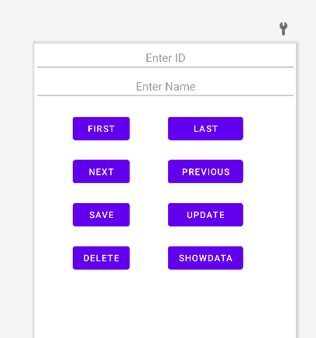

**Menu :**

**Mainactivity.kt :**

**package** com.example.menu_demo  
  
**import** androidx.appcompat.app.AppCompatActivity  
**import** android.os.Bundle  
**import** android.view.Menu  
**import** android.view.MenuItem  
**import** android.widget.Toast  
  
**class** MainActivity : AppCompatActivity() {  
 **override fun** onCreate(savedInstanceState: Bundle?) {  
 **super**.onCreate(savedInstanceState)  
 setContentView(R.layout.activity_main)  
 }  
 **override fun** onCreateOptionsMenu(menu: Menu):Boolean  
 {  
 menuInflater.inflate(R.menu.mainmenu, menu)  
 **return true** }  
  
 **override fun** onOptionsItemSelected(item: MenuItem): Boolean {  
  
 **when** (item.itemId) {  
 R.id.bca->Toast.makeText(**this**,**"BCA"**,Toast.LENGTH_LONG).show()  
 R.id.mca->Toast.makeText(**this**,**"MCA"**,Toast.LENGTH_LONG).show()  
 R.id.bscit->Toast.makeText(**this**,**"BSc(IT)"**,Toast.LENGTH_LONG).show()  
  
 }  
  
 **return super**.onOptionsItemSelected(item)  
 }  
}

**menu.xml : (to access this right click on res folder on the left side ->new->android resource file ->w=given name then select menu from dropdown list)**

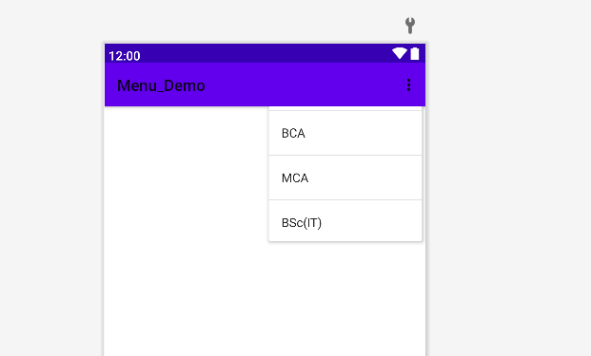

**You have to do nothing in mainactivity.xml file**

**Sum using textbox and button :**

**Mainactivity.kt:**

**package** com.example.p1_sum  
  
**import** androidx.appcompat.app.AppCompatActivity  
**import** android.os.Bundle  
**import** android.widget.Button  
**import** android.widget.EditText  
**import** android.widget.TextView  
  
**class** MainActivity : AppCompatActivity() {  
 **override fun** onCreate(savedInstanceState: Bundle?) {  
 **super**.onCreate(savedInstanceState)  
 setContentView(R.layout.*activity_main*)  
 **var** no1:EditText=findViewById(R.id.*etno1*);  
 **var** no2:EditText=findViewById(R.id.*etno2*);  
 **var** tv:TextView=findViewById(R.id.*textView*);  
 **var** btnadd:Button=findViewById(R.id.*button*);  
 **var** btnsub:Button=findViewById(R.id.*button2*);  
 **var** btnmul:Button=findViewById(R.id.*button3*);  
 **var** btndiv:Button=findViewById(R.id.*button4*);  
  
  
 btnadd.setOnClickListener**{  
 var** ans=no1.*text*.toString().*toInt*()+no2.*text*.toString().*toInt*();  
 tv.*text*= **"The answer is "**+ ans.toString();  
 **}** btnsub.setOnClickListener**{  
 var** ans=no1.*text*.toString().*toInt*()-no2.*text*.toString().*toInt*();  
 tv.*text*= **"The answer is "**+ ans.toString();  
 **}** btnmul.setOnClickListener**{  
 var** ans=no1.*text*.toString().*toInt*() * no2.*text*.toString().*toInt*();  
 tv.*text*= **"The answer is "** + ans.toString();  
 **}** btndiv.setOnClickListener**{  
 var** ans=no1.*text*.toString().*toFloat*()/no2.*text*.toString().*toFloat*();  
 tv.*text*= **"The answer is "**+ ans.toString();  
 **}** }  
}

**mainactivity.xml:**

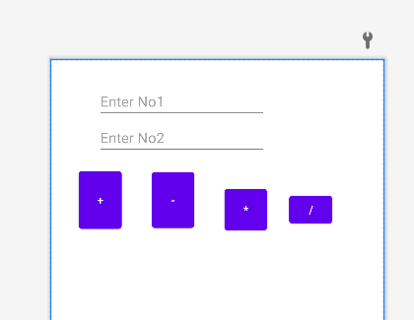

**Radio button and checkbox :**

**Mainactivity.kt :**

**package** com.example.radiobuttonandcheckbox  
  
**import** androidx.appcompat.app.AppCompatActivity  
**import** android.os.Bundle  
**import** android.widget.Button  
**import** android.widget.CheckBox  
**import** android.widget.RadioButton  
**import** android.widget.Toast  
  
**class** MainActivity : AppCompatActivity() {  
 **override fun** onCreate(savedInstanceState: Bundle?) {  
 **super**.onCreate(savedInstanceState)  
 setContentView(R.layout.activity_main)  
  
 **var** rm:RadioButton=findViewById(R.id.radioButtonmale);  
 **var** rf:RadioButton=findViewById(R.id.radioButtonfemale);  
 rm.setOnClickListener**{** Toast.makeText(**this**,**"Male"**,Toast.LENGTH_LONG).show();  
 **}** rf.setOnClickListener**{** Toast.makeText(**this**,**"Female"**,Toast.LENGTH_LONG).show();  
 **}  
  
 val** cbbca:CheckBox = findViewById(R.id.checkBoxbca)  
 **val** cbbsc:CheckBox = findViewById(R.id.checkBoxbsc)  
 **val** cbmca: CheckBox = findViewById(R.id.checkBoxmca)  
 **var** btn:Button=findViewById(R.id.button);  
 btn.setOnClickListener **{  
 var** str:String=**""  
 if**(cbbca.isChecked) {  
 str = str + **" BCA"** }  
 **if** (cbbsc.isChecked)  
 {  
 str = str + **" BSc(IT)"** }  
 **if** (cbmca.isChecked)  
 {  
 str = str + **" MCA"** }  
 Toast.makeText(**this**,str,Toast.LENGTH_LONG).show();  
 **}** }  
}

**mainactiviyt.xml:**

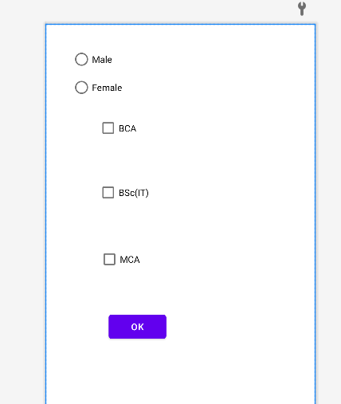

**Database with menu :**

**Dbhelper.kt:**

**package** com.charusat.registerform  
  
**import** android.content.Context  
**import** android.database.sqlite.SQLiteDatabase  
**import** android.database.sqlite.SQLiteOpenHelper  
  
**class** Dbhelper (context: Context):SQLiteOpenHelper (context,**"mydatabase"**,**null**,1)  
{  
 **override fun** onCreate(db: SQLiteDatabase?) {  
 **val** create_table = **"CREATE TABLE STDINFO(s_name TEXT PRIMARY KEY , s_email TEXT, s_phn BIGINTEGER , s_gender TEXT, s_caste TEXT, s_doc TEXT, s_bd DATE )"** db?.execSQL(create_table)  
 }  
  
 **override fun** onUpgrade(db: SQLiteDatabase?, oldVersion: Int, newVersion: Int) {  
 **val** drop_table = **"DROP TABLE IF EXISTS STDINFO"** db?.execSQL(drop_table)  
 onCreate(db)  
 }  
  
  
}

**mainactivity.kt:**

**package** com.charusat.registerform  
  
**import** android.content.Intent  
**import** androidx.appcompat.app.AppCompatActivity  
**import** android.os.Bundle  
**import** android.view.Menu  
**import** android.view.MenuItem  
  
**class** MainActivity : AppCompatActivity() {  
 **override fun** onCreate(savedInstanceState: Bundle?) {  
 **super**.onCreate(savedInstanceState)  
 setContentView(R.layout.activity_main)  
  
  
 }  
  
 **override fun** onCreateOptionsMenu(menu: Menu?): Boolean {  
 menuInflater.inflate(R.menu.main_menu,menu)  
 **return super**.onCreateOptionsMenu(menu)  
 **return true** }  
  
 **override fun** onOptionsItemSelected(item: MenuItem): Boolean {  
 startActivity(Intent(**this**,MainActivity2::**class**.java))  
 **return super**.onOptionsItemSelected(item)  
  
 }  
}

**mainactivity2.kt:**

**package** com.charusat.registerform  
  
**import** android.content.ContentValues  
**import** android.content.Context  
**import** android.database.sqlite.SQLiteDatabase  
**import** android.media.MediaExtractor.CasInfo  
**import** androidx.appcompat.app.AppCompatActivity  
**import** android.os.Bundle  
**import** android.view.View  
**import** android.widget.AdapterView  
**import** android.widget.ArrayAdapter  
**import** android.widget.Button  
**import** android.widget.CalendarView  
**import** android.widget.CheckBox  
**import** android.widget.EditText  
**import** android.widget.RadioButton  
**import** android.widget.Spinner  
**import** android.widget.Toast  
  
  
**class** MainActivity2 : AppCompatActivity() {  
 **lateinit var** gen:String  
 **var** doc:String=**""  
 val** cast:Array<String> = arrayOf(**"open"**,**"sc"**,**"ST"**,**"OBC"**)  
 **lateinit var** casteinfo:String  
 **lateinit var** datedata:String  
  
 **override fun** onCreate(savedInstanceState: Bundle?) {  
 **super**.onCreate(savedInstanceState)  
 setContentView(R.layout.activity_main2)  
 **var** helper =Dbhelper(applicationContext)  
 **var** db1 : SQLiteDatabase=helper.readableDatabase  
 **var** rs=db1.rawQuery(**"select * from STDINFO"**,**null**)  
 **var** sp:Spinner=findViewById(R.id.spinner)  
 **var** cal:CalendarView=findViewById(R.id.calendarView)  
 **var** name:EditText=findViewById(R.id.etname)  
 **var** email:EditText=findViewById(R.id.etmail)  
 **var** phone:EditText=findViewById(R.id.etphn)  
 **var** rm:RadioButton=findViewById(R.id.rbmale)  
 **var** rf:RadioButton=findViewById(R.id.rbfemale)  
 **var** ck1:CheckBox=findViewById(R.id.checkBox)  
 **var** ck2:CheckBox=findViewById(R.id.checkBox2)  
 **var** bnsub:Button=findViewById(R.id.Submit)  
  
 rf.setOnClickListener **{** gen =**"female"  
 }** rm.setOnClickListener **{** gen=**"male"  
 }** ck1.setOnClickListener **{** doc = **"doc + 10th"  
 }** ck2.setOnClickListener **{** doc = **"doc + 12th"  
 }  
 val** adpater:ArrayAdapter<String> =ArrayAdapter<String>(**this**,android.R.layout.select_dialog_item,cast)  
 sp.setAdapter(adpater)  
  
 sp.onItemSelectedListener = **object** :AdapterView.OnItemSelectedListener{  
 **override fun** onItemSelected(  
 parent: AdapterView<*>?,  
 view: View?,  
 position: Int,  
 id: Long  
 )  
 {  
 casteinfo = sp.selectedItem.toString()  
 }  
  
 **override fun** onNothingSelected(parent: AdapterView<*>?) {  
  
  
 }  
  
 }  
  
 cal.setOnDateChangeListener **{** view, year, month, dayOfMonth **->** datedata=dayOfMonth.toString()+**"/"**+(month + 1).toString()+**"/"**+year.toString()  
 **}** bnsub.setOnClickListener **{  
 var** cv = ContentValues()  
 cv.put(**"s_name"**,name.text.toString())  
 cv.put(**"s_email"**,email.text.toString())  
 cv.put(**"s_phn"**,phone.text.toString())  
 cv.put(**"s_gender"**,gen)  
 cv.put(**"s_caste"**,casteinfo)  
 cv.put(**"s_doc"**,doc)  
 cv.put(**"s_bd"**,datedata)  
 db1.insert(**"STDINFO"**,**null**,cv)  
 rs.requery()  
 Toast.makeText(**this**,**"recored inserted"**,Toast.LENGTH_LONG).show()  
 **}** }  
  
}

**mainactivity.xml : nithing to write as menu will stick on this page through code**

**menu.xml :**



**Mainactiivyt2.xml:**

**Make registration form**

**Shared preferences :**

**Mainactivity.kt :**

**package** com.example.sharedpreference_demo  
  
  
**import** android.os.Bundle  
**import** android.widget.Button  
**import** android.widget.EditText  
**import** android.widget.Toast  
**import** androidx.appcompat.app.AppCompatActivity  
  
  
**class** MainActivity : AppCompatActivity() {  
  
 **override fun** onCreate(savedInstanceState: Bundle?) {  
 **super**.onCreate(savedInstanceState)  
 setContentView(R.layout.activity_main)  
  
 **var** btn_save:Button=findViewById(R.id.btnSave)  
 **var** btn_clr:Button=findViewById(R.id.buttonclr)  
  
 **try** {  
 loaddata()  
 }  
 **catch** (e:Exception)  
 {  
 Toast.makeText(**this**,e.toString(),Toast.LENGTH_SHORT).show()  
 }  
 btn_save.setOnClickListener **{** savedata()  
 **}** btn_clr.setOnClickListener**{  
 val** preferences = getSharedPreferences(**"FirstSharedPreferences"**, 0)  
 **var** etunm11:EditText=findViewById(R.id.edtUsername)  
 **var** etpw11:EditText=findViewById(R.id.edtpw)  
  
 preferences.edit().remove(**"name"**).commit()  
 preferences.edit().remove(**"pw"**).commit()  
 etunm11.text.clear()  
 etpw11.text.clear()  
  
 **}** }  
  
 **private fun** savedata() {  
  
 **var** etunm:EditText=findViewById(R.id.edtUsername)  
 **var** etpw:EditText=findViewById(R.id.edtpw)  
 **var** sharedPreferences = getSharedPreferences(**"FirstSharedPreferences"**, MODE_PRIVATE)  
  
 **val** editor = sharedPreferences.edit()  
 editor.apply **{** putString(**"name"**,etunm.text.toString())  
 putString(**"pw"**, etpw.text.toString())  
  
  
 **}**.apply()  
 Toast.makeText(**this**,**"Saved the Preference"**, Toast.LENGTH_SHORT).show()  
 }  
  
 **private fun** loaddata() {  
  
 **var** etunm1:EditText=findViewById(R.id.edtUsername)  
 **var** etpw1:EditText=findViewById(R.id.edtpw)  
 **val** sharedPreferences = getSharedPreferences(**"FirstSharedPreferences"**, MODE_PRIVATE)  
 **val** stringval:String? = sharedPreferences.getString(**"name"**,**null**)  
 **val** stringval1:String? = sharedPreferences.getString(**"pw"**,**null**)  
 etunm1.setText(stringval)  
 etpw1.setText(stringval1)  
  
 }  
  
  
}

**mainactivity.xml :**

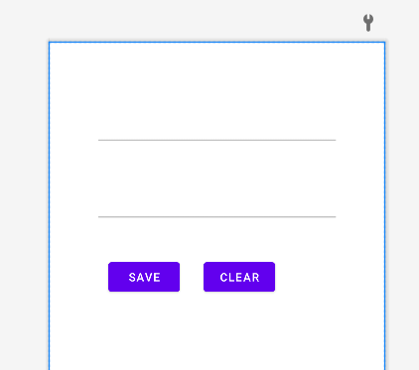

**Spinner demo :**

**Mainactivity.kt :**

**package** com.example.spinnerdemo  
  
**import** androidx.appcompat.app.AppCompatActivity  
**import** android.os.Bundle  
**import** android.view.View  
**import** android.widget.*  
  
**class** MainActivity : AppCompatActivity() {  
  
 **val** colors:Array<String> = arrayOf(**"Select any Color"**,**"Red"**,**"Green"**,**"Blue"**,**"Yellow"**,)  
  
 **override fun** onCreate(savedInstanceState: Bundle?) {  
 **super**.onCreate(savedInstanceState)  
 setContentView(R.layout.activity_main)  
  
 **var** sp:Spinner=findViewById(R.id.spinner);  
 **var** tv:TextView=findViewById(R.id.textView)  
 **val** adapter: ArrayAdapter<String> = ArrayAdapter<String>(**this**,android.R.layout.select_dialog_item, colors)  
 sp.setAdapter(adapter)  
 sp.onItemSelectedListener=**object** :AdapterView.OnItemSelectedListener{  
 **override fun** onItemSelected( parent: AdapterView<*>?, view: View?, position: Int, id: Long)  
 {  
 Toast.makeText(**this**@MainActivity, **"You have selected "**+colors[position], Toast.LENGTH_SHORT).show()  
 tv.setText(sp.selectedItem.toString())  
 }  
  
 **override fun** onNothingSelected(parent: AdapterView<*>?) {  
 *// TODO("Not yet implemented")* }  
  
 }  
 }  
}

**mainactivty.xml :**

**take one spinner from palette and textview too as per code**

**togglebutton and switch :**

**maianctivyt.kt :**

**package** com.example.togglebuttonandswitch  
  
**import** androidx.appcompat.app.AppCompatActivity  
**import** android.os.Bundle  
**import** android.widget.Switch  
**import** android.widget.Toast  
**import** android.widget.ToggleButton  
  
**class** MainActivity : AppCompatActivity() {  
 **override fun** onCreate(savedInstanceState: Bundle?) {  
 **super**.onCreate(savedInstanceState)  
 setContentView(R.layout.activity_main)  
  
 **val** toggle: ToggleButton = findViewById(R.id.toggleButton)  
 toggle.setOnCheckedChangeListener**{**_,isChecked**->  
 if** (isChecked) {  
 Toast.makeText(**this**,**"ON"**,Toast.LENGTH_LONG).show();  
 } **else** {  
 Toast.makeText(**this**,**"OFF"**,Toast.LENGTH_LONG).show();  
 }  
 **}  
  
 val** switchbutton:Switch=findViewById(R.id.switch1)  
 switchbutton.setOnCheckedChangeListener **{** _, isChecked **->  
 if** (isChecked) {  
 Toast.makeText(**this**,**"ON"**,Toast.LENGTH_LONG).show();  
 } **else** {  
 Toast.makeText(**this**,**"OFF"**,Toast.LENGTH_LONG).show();  
 }  
 **}** }  
}

**mainactiviyt.xml:**

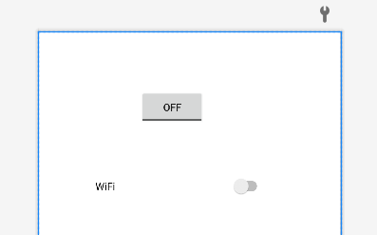

**Implicit intent with charusat :**

**Mainactivity.kt :**

**package** com.example.impliciteintentcharusat  
  
**import** android.content.Intent  
**import** android.net.Uri  
**import** androidx.appcompat.app.AppCompatActivity  
**import** android.os.Bundle  
**import** android.widget.Button  
  
**class** MainActivity : AppCompatActivity() {  
 **override fun** onCreate(savedInstanceState: Bundle?) {  
 **super**.onCreate(savedInstanceState)  
 setContentView(R.layout.activity_main)  
 **var** btn:Button=findViewById(R.id.button);  
  
 btn.setOnClickListener **{  
 var** intent = Intent(Intent.ACTION_VIEW)  
 intent.setData(Uri.parse(**"https://www.tutorialkart.com/"**))  
 startActivity(intent)  
 **}** }  
}

**to load charusat website we need to give internet permission in manifest file**

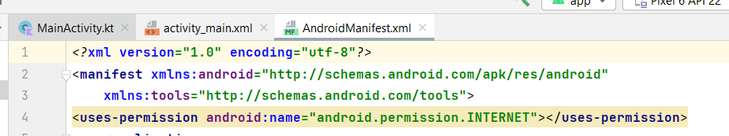

**mainactiviyt.xml :**

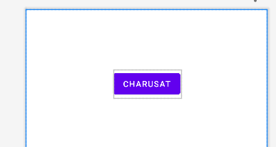

**Login with intent :**

**Mainactivity.kt :**

**package** com.example.loginwithintent  
  
**import** android.content.Intent  
**import** androidx.appcompat.app.AppCompatActivity  
**import** android.os.Bundle  
**import** android.widget.Button  
**import** android.widget.EditText  
**import** android.widget.Toast  
  
**class** MainActivity : AppCompatActivity() {  
 **override fun** onCreate(savedInstanceState: Bundle?) {  
 **super**.onCreate(savedInstanceState)  
 setContentView(R.layout.activity_main)  
 **var** unm:EditText=findViewById(R.id.txtunm);  
 **var** ups:EditText=findViewById(R.id.txtupass);  
 **var** btn:Button=findViewById(R.id.buttonlogin)  
 btn.setOnClickListener **{  
 if** (unm.text.toString()==**"admin"** && ups.text.toString()==**"admin"**)  
 {  
 **var** intent = Intent(**this**, MyMainPage::**class**.java)  
 intent.putExtra(**"name"**, unm.text.toString())  
 intent.putExtra(**"id"**,ups.text.toString())  
 startActivity(intent)  
 }  
 **else** {  
 Toast.makeText(**this**,**"Login Fail"**,Toast.LENGTH_LONG).show()  
  
 }  
  
 **}** }  
}

**my_mainpage.kt :**

**(second page )**

**package** com.example.loginwithintent  
  
**import** androidx.appcompat.app.AppCompatActivity  
**import** android.os.Bundle  
**import** android.widget.TextView  
  
**class** MyMainPage : AppCompatActivity() {  
 **override fun** onCreate(savedInstanceState: Bundle?) {  
 **super**.onCreate(savedInstanceState)  
 setContentView(R.layout.activity_my_main_page)  
  
 **var** tv:TextView=findViewById(R.id.textView);  
  
 tv.setText(**"Welcome to "**+intent.getStringExtra(**"name"**))  
  
 }  
}

**mainactivity.xml:**

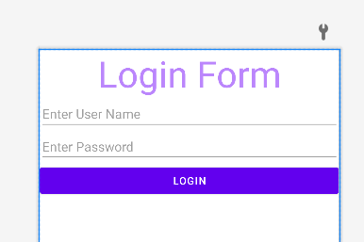

**My_mainpage.xml:**

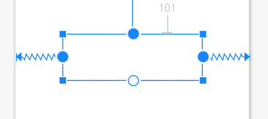

**One text view is taken**

**Activity life cycle :**

**Mainactivity.kt:**

**package** com.example.p2_activitylife_cycle  
  
**import** androidx.appcompat.app.AppCompatActivity  
**import** android.os.Bundle  
**import** android.util.Log  
  
**class** MainActivity : AppCompatActivity() {  
 **override fun** onCreate(savedInstanceState: Bundle?) {  
 **super**.onCreate(savedInstanceState)  
 setContentView(R.layout.activity_main)  
 Log.d(**"tag"**,**"OnCreate called"**);  
 }  
  
 **override fun** onStart() {  
 **super**.onStart()  
 Log.d(**"tag"**,**"OnStart called"**);  
 }  
  
 **override fun** onResume() {  
 **super**.onResume()  
 Log.d(**"tag"**,**"OnResume called"**);  
  
 }  
  
 **override fun** onRestart() {  
 **super**.onRestart()  
 Log.d(**"tag"**,**"OnRestart called"**);  
  
 }  
  
 **override fun** onPause() {  
 **super**.onPause()  
 Log.d(**"tag"**,**"OnPause called"**);  
  
 }  
  
 **override fun** onStop() {  
 **super**.onStop()  
 Log.d(**"tag"**,**"OnStop called"**);  
  
 }  
  
  
 **override fun** onDestroy() {  
 **super**.onDestroy()  
 Log.d(**"tag"**,**"OnDestroy called"**);  
  
 }  
}

**mainactiviyt.xml :**

**nothing to od here**

**login form :**

**mainactivity.kt :**

**package** com.example.p3_loginform_final  
  
**import** android.content.Intent  
**import** androidx.appcompat.app.AppCompatActivity  
**import** android.os.Bundle  
**import** android.widget.Button  
**import** android.widget.EditText  
**import** android.widget.Toast  
  
**class** MainActivity : AppCompatActivity() {  
 **override fun** onCreate(savedInstanceState: Bundle?) {  
 **super**.onCreate(savedInstanceState)  
 setContentView(R.layout.*activity_main*)  
  
 **var** etid: EditText =findViewById(R.id.*editTextTextPersonName*);  
 **var** etpass: EditText =findViewById(R.id.*editTextTextPassword*);  
 **var** btn: Button =findViewById(R.id.*btnlogin*);  
  
  
  
 btn.setOnClickListener**{  
  
 var** nm=etid.*text*.toString();  
 **var** ps=etpass.*text*.toString();  
 **if** (nm==**"kamini"** && ps==**"kamini"**) {  
  
 **var** intent = Intent(**this**, MainActivity2::**class**.*java*)  
 intent.putExtra(**"name"**, nm)  
 startActivity(intent)  
  
 }  
 **}** }  
}

**mainactiviyt2.kt:**

**package** com.example.p3_loginform_final  
  
**import** androidx.appcompat.app.AppCompatActivity  
**import** android.os.Bundle  
**import** android.widget.TextView  
  
**class** MainActivity2 : AppCompatActivity() {  
 **override fun** onCreate(savedInstanceState: Bundle?) {  
 **super**.onCreate(savedInstanceState)  
 setContentView(R.layout.*activity_main2*)  
 **var** tv:TextView=findViewById(R.id.*textView*);  
  
 **var** ss:String = **"welcone to "**+*intent*.getStringExtra(**"name"**).*toString*();  
 tv.setText(ss);  
 }  
}

**mainactiviyt.xml :**

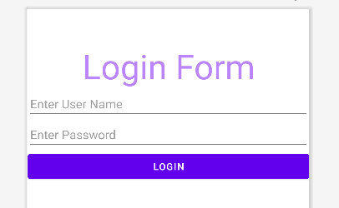

**Mainactiviyt2.xml :**

**Nothing on put one textview to show data**

**Progress bar:**

**Mainactvity.kt:**

**package** com.example.progressbar  
  
**import** android.os.Bundle  
**import** android.view.View  
**import** android.widget.Button  
**import** android.widget.ProgressBar  
**import** android.widget.TextView  
**import** androidx.appcompat.app.AppCompatActivity  
**import** java.util.logging.Handler  
  
**class** MainActivity : AppCompatActivity() {  
  
 **private var** progressBar: ProgressBar? = **null  
 private var** i = 0  
 **private var** txtView: TextView? = **null  
 private val** handler = android.os.Handler()  
  
 **override fun** onCreate(savedInstanceState: Bundle?) {  
 **super**.onCreate(savedInstanceState)  
 setContentView(R.layout.activity_main)  
  
 *//progressBar = findViewById<ProgressBar>(R.id.progress_Bar) as ProgressBar  
 //txtView = findViewById<TextView>(R.id.text_view)  
 //val btn = findViewById<Button>(R.id.show_button)* **var** progressBar:ProgressBar=findViewById(R.id.progress_Bar);  
 **var** txtView:TextView=findViewById(R.id.text_view);  
 **var** btn:Button=findViewById(R.id.show_button);  
  
 btn.setOnClickListener **{** progressBar.visibility = View.VISIBLE  
 i = progressBar.progress  
  
 Thread(Runnable **{  
 while** (i < 100) {  
 i += 1  
  
 handler.post(Runnable **{** progressBar.progress = i  
 txtView.text = i.toString() + **"/"** + progressBar!!.max  
  
 **}**)  
 **try** {  
 Thread.sleep(5000)  
 } **catch** (e: InterruptedException) {  
 e.printStackTrace()  
 }  
 }  
  
 progressBar.visibility = View.INVISIBLE  
  
 **}**).start()  
 **}** }  
}  
  
**private fun** Handler.post(runnable: Runnable) {  
  
}

**mainactivyt.xml:**

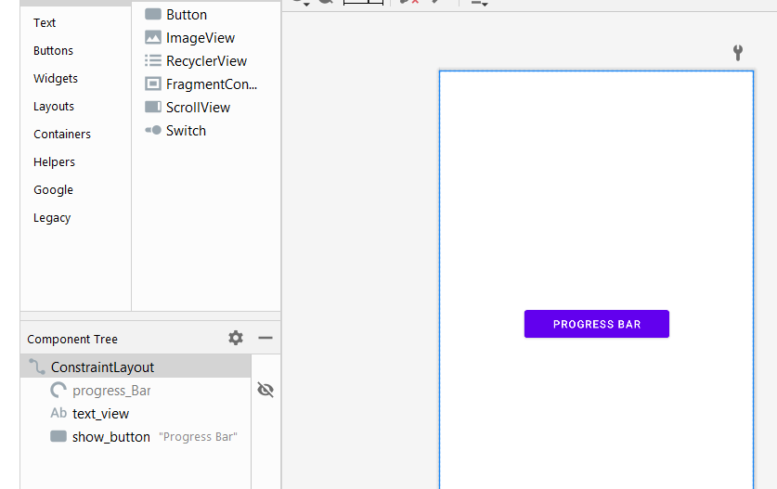

**Rating bar :**

**Mainactvity.kt:**

**package** com.example.ratingbaronline  
  
**import** androidx.appcompat.app.AppCompatActivity  
**import** android.os.Bundle  
**import** android.widget.RatingBar  
**import** android.widget.Toast  
  
**class** MainActivity : AppCompatActivity() {  
 **override fun** onCreate(savedInstanceState: Bundle?) {  
 **super**.onCreate(savedInstanceState)  
 setContentView(R.layout.*activity_main*)  
 **var** rb:RatingBar=findViewById(R.id.*ratingBar*);  
 rb.setOnRatingBarChangeListener **{** ratingBar, fl, b **->** Toast.makeText(**this**,fl.toString(),Toast.*LENGTH_LONG*).show()  
 **}** }  
}

**mainactivity.xml:**

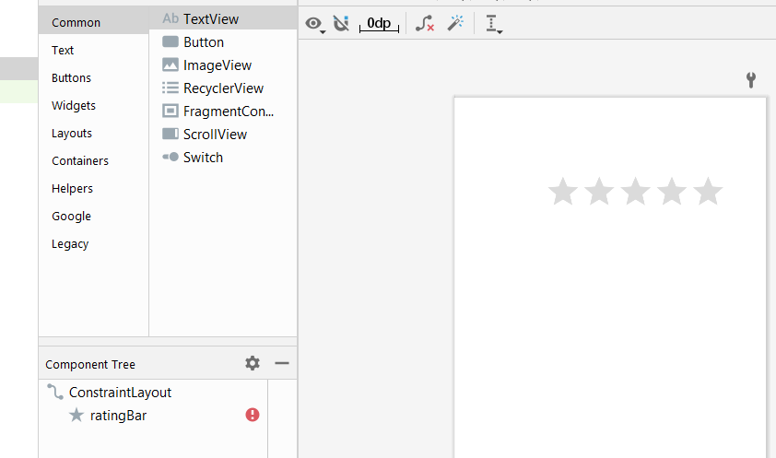

**Videoview :**

**Mainactivity.kt:**

**package** com.example.videoview  
  
**import** android.net.Uri  
**import** androidx.appcompat.app.AppCompatActivity  
**import** android.os.Bundle  
**import** android.widget.MediaController  
**import** android.widget.VideoView  
**import** java.util.logging.Level.parse  
  
**class** MainActivity : AppCompatActivity() {  
 **override fun** onCreate(savedInstanceState: Bundle?) {  
 **super**.onCreate(savedInstanceState)  
 setContentView(R.layout.activity_main)  
 **var** videoview:VideoView=findViewById(R.id.videoView)  
 **var** mediaController:MediaController = MediaController(**this**)  
  
 videoview.setVideoPath(**"android.resource://"** + getPackageName() + **"/"** + R.raw.video1)  
 videoview.setMediaController(mediaController)  
 videoview.start()  
  
  
  
 }  
}

**mainactvity.xml:**

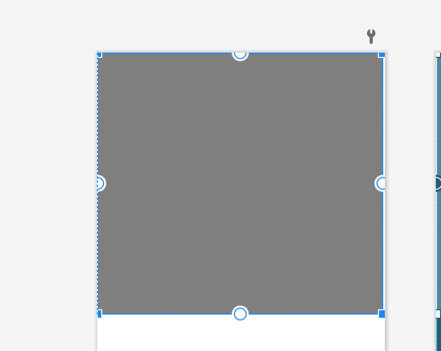

**Add video to raw folder in res file by right clicking on it -> open in -> explorer -> cop paste the video in raw folder**

**Webview :**

**Mainactivity.kt :**

**package** com.example.webview  
  
**import** android.net.Uri  
**import** androidx.appcompat.app.AppCompatActivity  
**import** android.os.Bundle  
**import** android.webkit.WebView  
  
**class** MainActivity : AppCompatActivity() {  
 **override fun** onCreate(savedInstanceState: Bundle?) {  
 **super**.onCreate(savedInstanceState)  
 setContentView(R.layout.*activity_main*)  
  
 **var** webv:WebView=findViewById(R.id.*webview*);  
 webv.loadUrl(**"https://charusat.ac.in/"**)  
 }  
}

**to load charusat website we need to give internet permission in manifest file**



**mainactivity.xml :**

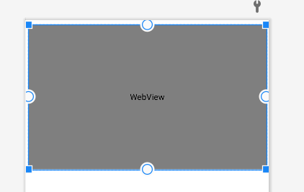

**Listview :**

**Mainactivity.kt:**

**package** com.example.listviewdemo  
  
**import** androidx.appcompat.app.AppCompatActivity  
**import** android.os.Bundle  
**import** android.widget.ArrayAdapter  
**import** android.widget.ListView  
**import** android.widget.Toast  
  
**class** MainActivity : AppCompatActivity() {  
 **override fun** onCreate(savedInstanceState: Bundle?) {  
 **super**.onCreate(savedInstanceState)  
 setContentView(R.layout.activity_main)  
  
 **var** listview:ListView=findViewById(R.id.listview1)  
 **val** names = arrayOf(**"C"**,**"C++"**,**"JAVA"**,**"ANDROID"**,**"PYTHON"**)  
 **val** arrayAdapter:ArrayAdapter<String> = ArrayAdapter(**this**,android.R.layout.simple_list_item_1,names)  
 listview.adapter=arrayAdapter  
 *// listview.setOnItemClickListener { adapterView, view, position, id ->  
 // Toast.makeText(this,names[id],Toast.LENGTH_LONG).show()  
  
 // }* listview.setOnItemClickListener **{** adapterView, view, i, l **->** Toast.makeText(**this**,l.toString(),Toast.LENGTH_LONG).show()  
  
 **}** }  
}

**mainactivity.xml:**

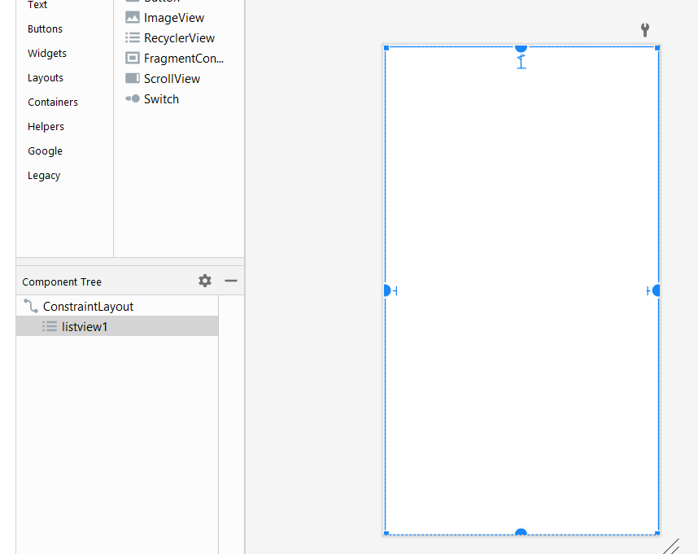

**Assignment 1 :**

**Name: Hetvi Soni**

**ID: 20BSIT165**

1. Create android UI application to accept two numbers and the display the sum of the number using Button and EditText.

package com.example.my_app   
   
import androidx.appcompat.app.AppCompatActivity   
import android.os.Bundle   
import android.widget.Button   
import android.widget.EditText   
import android.widget.TextView   
   
class MainActivity : AppCompatActivity() {   
    override fun onCreate(savedInstanceState: Bundle?) {   
        super.onCreate(savedInstanceState)   
        setContentView(R.layout.activity_main)   
   
        var etnm1 : EditText = findViewById(R.id.txtn1);   
        var etnm2 : EditText = findViewById(R.id.txtn2);   
        var btn : Button = findViewById(R.id.button);   
           
        btn.setOnClickListener **{**   
var n1 = etnm1.text.toString().toInt();   
            var n2 = etnm2.text.toString().toInt();   
            var sum = n1 + n2;   
            tv.text = "Addition is : "+sum.toString();   
        **}**   
}   
}

1. Create an Android application to demonstrate the Activity LifeCycle.
2. Create sample application with login module. (Check username and password). If user name and password is “admin” display message “Login successfully” on the screen.

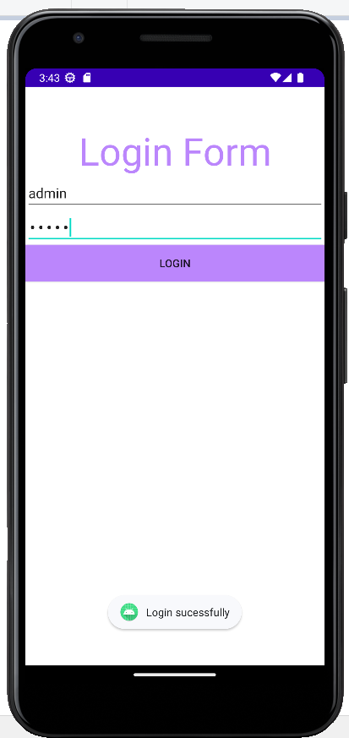

package com.example.login   
   
import android.content.Intent   
import androidx.appcompat.app.AppCompatActivity   
import android.os.Bundle   
import android.widget.Button   
import android.widget.EditText   
import android.widget.Toast   
   
class MainActivity : AppCompatActivity() {   
    override fun onCreate(savedInstanceState: Bundle?) {   
        super.onCreate(savedInstanceState)   
        setContentView(R.layout.activity_main)   
   
        var usnm : EditText = findViewById(R.id.txtnm);   
        var psw : EditText = findViewById(R.id.psw1);   
        var bn : Button = findViewById(R.id.btn);   
        bn.setOnClickListener **{**   
if (usnm.text.toString().equals("admin") && psw.text.toString().equals("admin")) {   
                Toast.makeText(this, "Login Successful", Toast.LENGTH_LONG).show();   
            }   
        **}**   
}   
}

**assignment 2 :**

Name : Soni Hetvi

Id : 20bsit165

1. Create calculator application with two EditText to enter numbers, 4 Buttons to perform Addition, Subtraction, Division, Multiplication and display answer into toast. (Check for blank value and 0 value input) (Use proper controls)

package com.example.my_app   
   
import androidx.appcompat.app.AppCompatActivity   
import android.os.Bundle   
import android.widget.Button   
import android.widget.EditText   
import android.widget.TextView   
   
class MainActivity : AppCompatActivity() {   
    override fun onCreate(savedInstanceState: Bundle?) {   
        super.onCreate(savedInstanceState)   
        setContentView(R.layout.*activity_main*)   
   
        var etnm1 : EditText = findViewById(R.id.*txtn1*);   
        var etnm2 : EditText = findViewById(R.id.*txtn2*);   
        var btn : Button = findViewById(R.id.*button*);   
        var btnsub : Button = findViewById(R.id.*btnsub*);   
        var btnmul : Button = findViewById(R.id.*btnmul*);   
        var btndiv : Button = findViewById(R.id.*btndiv*);   
        var tv : TextView = findViewById(R.id.*textView*);   
        btn.setOnClickListener **{**   
var n1 = etnm1.*text*.toString().*toInt*();   
            var n2 = etnm2.*text*.toString().*toInt*();   
            var sum = n1 + n2;   
            tv.*text* = "Addition is : "+sum.toString();   
        **}**   
btnsub.setOnClickListener **{**   
var n1 = etnm1.*text*.toString().*toInt*();   
            var n2 = etnm2.*text*.toString().*toInt*();   
            var sum = n1 - n2;   
            tv.*text* = "Subtraction is : "+sum.toString();   
        **}**   
btnmul.setOnClickListener **{**   
var n1 = etnm1.*text*.toString().*toInt*();   
            var n2 = etnm2.*text*.toString().*toInt*();   
            var sum = n1 * n2;   
            tv.*text* = "Multiplication is : "+sum.toString();   
        **}**   
btndiv.setOnClickListener **{**   
var n1 = etnm1.*text*.toString().*toInt*();   
            var n2 = etnm2.*text*.toString().*toInt*();   
            var sum = n1 / n2;   
            tv.*text* = "Division is : "+sum.toString();   
        **}**   
}   
}

1. Write an android application that will take basic student information (Student ID, Student Name, Student Branch, Student Contact No., Student Birth date) in one screen from user and display that information to other screen on submit button click of first screen) (Use proper controls)

package com.example.student_info   
   
import android.content.Intent   
import androidx.appcompat.app.AppCompatActivity   
import android.os.Bundle   
import android.widget.Button   
import android.widget.EditText   
   
class MainActivity : AppCompatActivity() {   
    override fun onCreate(savedInstanceState: Bundle?) {   
        super.onCreate(savedInstanceState)   
        setContentView(R.layout.*activity_main*)   
   
        var t1 : EditText = findViewById(R.id.*txt1*);   
        var t2 : EditText = findViewById(R.id.*txt2*);   
        var t3 : EditText = findViewById(R.id.*txt3*);   
        var t4 : EditText = findViewById(R.id.*txt4*);   
        var t5 : EditText = findViewById(R.id.*txt5*);   
        var bn : Button = findViewById(R.id.*button*);   
   
        bn.setOnClickListener **{**   
var id = t1.*text*.toString();   
            var nm = t2.*text*.toString();   
            var brnm = t3.*text*.toString();   
            var mono = t4.*text*.toString();   
            var bd = t5.*text*.toString();   
            var intent = Intent(this,Homepage::class.*java*)   
            intent.putExtra("ID",id)   
            startActivity(intent)   
            var intent1 = Intent(this,Homepage::class.java)   
            intent.putExtra("Name",nm)   
            startActivity(intent)   
            var intent2 = Intent(this,Homepage::class.java)   
            intent.putExtra("Branch Name",brnm)   
            startActivity(intent)   
            var intent3 = Intent(this,Homepage::class.java)   
            intent.putExtra("Contact Number",mono)   
            startActivity(intent)   
            var intent4 = Intent(this,Homepage::class.java)   
            intent.putExtra("Birth Date",bd)   
            startActivity(intent)   
        **}**   
}   
}

package com.example.student_info   
   
import androidx.appcompat.app.AppCompatActivity   
import android.os.Bundle   
import android.widget.TextView   
   
class Homepage : AppCompatActivity() {   
    override fun onCreate(savedInstanceState: Bundle?) {   
        super.onCreate(savedInstanceState)   
        setContentView(R.layout.*activity_homepage*)   
   
        var tv1 : TextView = findViewById(R.id.*textView*);   
        var tv2 : TextView = findViewById(R.id.*textView2*);   
        var tv3 : TextView = findViewById(R.id.*textView3*);   
        var tv4 : TextView = findViewById(R.id.*textView4*);   
        var tv5 : TextView = findViewById(R.id.*textView5*);   
        var s1 = intent.getStringExtra("ID").toString();   
        tv1.setText("ID : " +s1);   
        var s2 = intent.getStringExtra("Name").toString();   
        tv2.setText("NAME : " +s2);   
        var s3 = intent.getStringExtra("Branch Name").toString();   
        tv3.setText("BRANCH : " +s3);   
        var s4 = intent.getStringExtra("Contact Number").toString();   
        tv4.setText("CONTACT NO. : " +s4);   
        var s5 = intent.getStringExtra("Birth Date").toString();   
        tv5.setText("DATE OF BIRTH : " +s5);   
    }   
}

1. Create an Android application that should have 2 screens: Login Screen, Home Screen. When user start application for first time, Login screen should appear. User will login with Username: “admin” and Password: “admin”. After successful login, user will redirect to home screen. Where Welcome [Username] should be display. (Use explicit Intent)

package com.example.login   
   
import android.content.Intent   
import androidx.appcompat.app.AppCompatActivity   
import android.os.Bundle   
import android.widget.Button   
import android.widget.EditText   
import android.widget.Toast   
   
class MainActivity : AppCompatActivity() {   
    override fun onCreate(savedInstanceState: Bundle?) {   
        super.onCreate(savedInstanceState)   
        setContentView(R.layout.*activity_main*)   
   
        var usnm : EditText = findViewById(R.id.*txtnm*);   
        var psw : EditText = findViewById(R.id.*psw1*);   
        var bn : Button = findViewById(R.id.*btn*);   
        bn.setOnClickListener **{**   
if (usnm.*text*.toString().equals("admin") && psw.*text*.toString().equals("admin")) {   
                Toast.makeText(this, "Login Successful", Toast.*LENGTH_LONG*).show();   
            }   
            var intent = Intent(this,HomePage::class.*java*)   
            intent.putExtra("user name",usnm.*text*.toString())   
            startActivity(intent)   
        **}**   
}   
}

package com.example.login   
   
import androidx.appcompat.app.AppCompatActivity   
import android.os.Bundle   
import android.widget.TextView   
   
class HomePage : AppCompatActivity() {   
    override fun onCreate(savedInstanceState: Bundle?) {   
        super.onCreate(savedInstanceState)   
        setContentView(R.layout.*activity_home_page*)   
        var tv : TextView = findViewById(R.id.*textView*);   
        var s1 = *intent*.getStringExtra("user name").*toString*();   
        tv.setText("Welcome "+s1 +" !!");   
    }   
}

1. Open CHARUSAT website using Implicit Intent.

package com.example.open_website   
   
import android.content.Intent   
import android.net.Uri   
import androidx.appcompat.app.AppCompatActivity   
import android.os.Bundle   
import android.widget.Button   
   
class MainActivity : AppCompatActivity() {   
    override fun onCreate(savedInstanceState: Bundle?) {   
        super.onCreate(savedInstanceState)   
        setContentView(R.layout.*activity_main*)   
        var bn : Button = findViewById(R.id.*button*);   
        bn.setOnClickListener **{**   
var intent = Intent(Intent.*ACTION_VIEW*)   
            intent.setData(Uri.parse("https://www.charusat.ac.in"));   
            startActivity(intent)   
        **}**   
}   
}

1. Create Application of Alert Dialog Box contains following three components.
2. Title
3. Message
4. Buttons (that trigger Negative and Positive Actions)

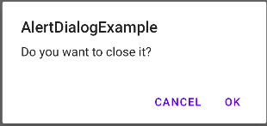

package com.example.alertbox   
   
import android.content.DialogInterface   
import androidx.appcompat.app.AppCompatActivity   
import android.os.Bundle   
import android.widget.Button   
import androidx.appcompat.app.AlertDialog   
   
class MainActivity : AppCompatActivity() {   
    override fun onCreate(savedInstanceState: Bundle?) {   
        super.onCreate(savedInstanceState)   
        setContentView(R.layout.*activity_main*)   
        var bn : Button = findViewById(R.id.*button*);   
        bn.setOnClickListener **{**   
var dialogBuilder = AlertDialog.Builder(this);   
            dialogBuilder.setTitle("Alert Dialog Example")   
            dialogBuilder.setMessage("Do you want to close it ? ")   
            dialogBuilder.setPositiveButton("OK",DialogInterface.OnClickListener**{**   
dialog,id**->**finish();   
            **}**)   
            dialogBuilder.setNegativeButton("Cancel",DialogInterface.OnClickListener **{**   
dialog, id **->** dialog.cancel();   
            **}**).show();   
        **}**   
}   
}

1. Display Toast message by clicking on Image Button and open CHARUSAT website using webview.

class MainActivity : AppCompatActivity() {

    override fun onCreate(savedInstanceState: Bundle?) {

        super.onCreate(savedInstanceState)

        setContentView(R.layout.activity_main)

Var webv:webview=findviewById(R.id.webview);

Webv.loadUrl(“https://charusat.ac.in/”)

}

}

1. Write a program using Radiobutton and display message in Toast.

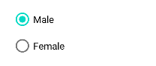

package com.example.radio_button   
   
import androidx.appcompat.app.AppCompatActivity   
import android.os.Bundle   
import android.widget.RadioButton   
import android.widget.Toast   
   
class MainActivity : AppCompatActivity() {   
    override fun onCreate(savedInstanceState: Bundle?) {   
        super.onCreate(savedInstanceState)   
        setContentView(R.layout.*activity_main*)   
        var rb : RadioButton = findViewById(R.id.*radioButton*);   
        var rb1 : RadioButton = findViewById(R.id.*radioButton2*);   
        rb.setOnClickListener **{**   
Toast.makeText(this,"male",Toast.*LENGTH_LONG*).show()   
        **}**   
rb1.setOnClickListener **{**   
Toast.makeText(this,"female",Toast.*LENGTH_LONG*).show()   
        **}**   
}   
}

1. Write a program using Checkbox and display message in Toast

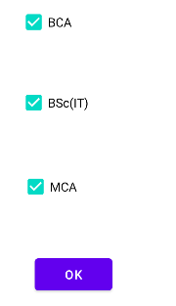

package com.example.check_box   
   
import androidx.appcompat.app.AppCompatActivity   
import android.os.Bundle   
import android.widget.Button   
import android.widget.CheckBox   
import android.widget.Toast   
   
class MainActivity : AppCompatActivity() {   
    override fun onCreate(savedInstanceState: Bundle?) {   
        super.onCreate(savedInstanceState)   
        setContentView(R.layout.activity_main)   
        var cb1 : CheckBox = findViewById(R.id.cb1);   
        var cb2 : CheckBox = findViewById(R.id.cb2);   
        var cb3 : CheckBox = findViewById(R.id.cb3);   
        var bn : Button = findViewById(R.id.button);   
        bn.setOnClickListener **{**   
var str : String = "";   
            if(cb1.isChecked)   
            {   
                str = str + "BSC IT";   
            }   
            if(cb2.isChecked)   
            {   
                str = str + "BCA";   
            }   
            if(cb3.isChecked)   
            {   
                str = str + "MCA";   
            }   
            Toast.makeText(this,str,Toast.LENGTH_LONG).show()   
        **}**   
}   
}

1. Write a program for Toggle Button and switch and print the status of the button in Toast.

package com.example.toggle_button   
   
import androidx.appcompat.app.AppCompatActivity   
import android.os.Bundle   
import android.widget.Switch   
import android.widget.Toast   
import android.widget.ToggleButton   
   
class MainActivity : AppCompatActivity() {   
    override fun onCreate(savedInstanceState: Bundle?) {   
        super.onCreate(savedInstanceState)   
        setContentView(R.layout.*activity_main*)   
        var tb: ToggleButton = findViewById(R.id.*toggleButton*);   
        var sw: Switch = findViewById(R.id.*switch1*);   
        sw.setOnCheckedChangeListener **{** _, checked **->**   
if (sw.*isChecked*) {   
                Toast.makeText(this, "ON", Toast.*LENGTH_LONG*).show()   
            }   
            else {   
                Toast.makeText(this, "OFF", Toast.*LENGTH_LONG*).show()   
            }   
        **}**   
tb.setOnCheckedChangeListener **{** _, checked **->**   
if (tb.*isChecked*) {   
                Toast.makeText(this, "ON", Toast.*LENGTH_LONG*).show()   
            }   
            else {   
                Toast.makeText(this, "OFF", Toast.*LENGTH_LONG*).show()   
            }   
        **}**   
}   
}

1. Display the states name in AutoCompleteTextView and MultiAutoCompleteTextView.

package com.example.a2_autocompletetextview

import androidx.appcompat.app.AppCompatActivity

import android.os.Bundle

import android.widget.ArrayAdapter

import android.widget.AutoCompleteTextView

import android.widget.MultiAutoCompleteTextView

class MainActivity : AppCompatActivity() {

     val state = arrayOf("Gujarat", "Goa", "MP", "Maharashtra", "UP")

    override fun onCreate(savedInstanceState: Bundle?) {

        super.onCreate(savedInstanceState)

        setContentView(R.layout.activity_main)

        var autoTextView:AutoCompleteTextView=findViewById(R.id.autoCompleteTextView);

        val adapter: ArrayAdapter<String> = ArrayAdapter<String>(this,android.R.layout.select_dialog_item, state)

        autoTextView.setAdapter(adapter)

        autoTextView.threshold = 1

        var  mautoTextView: MultiAutoCompleteTextView = findViewById(R.id.multiAutoCompleteTextView);

        mautoTextView.setAdapter(adapter);

        mautoTextView.setTokenizer(MultiAutoCompleteTextView.CommaTokenizer());

        mautoTextView.threshold = 1

    }

}

11. Display your Birthdate in TextView using CalenderView, Date Picker, Time Piker.

 var cn:CalendarView=findViewById(R.id.calendarView)

        var tx:TextView=findViewById(R.id.textView)

        var msg:String=" "

        var msg1:String=" "

        var btn:Button=findViewById(R.id.button)

        var tp:TimePicker=findViewById(R.id.time)

        cn.setOnDateChangeListener { calendarView, i, i2, i3 ->

            msg = i3.toString()+ "/" + (i2+1).toString() +"/" + i.toString()

        }

        tp.setOnTimeChangedListener { view, hourOfDay, minute ->

            msg1= " " +hourOfDay.toString() + ":" + minute.toString()

        }

        btn.setOnClickListener {

            tx.text=msg.toString() + msg1.toString()

        }

12 Display Charusat website using WebView

class MainActivity : AppCompatActivity() {

    override fun onCreate(savedInstanceState: Bundle?) {

        super.onCreate(savedInstanceState)

        setContentView(R.layout.activity_main)

Var webv:webview=findviewById(R.id.webview);

Webv.loadUrl(“https://charusat.ac.in/”)

}

}

1. Display any Video using VideoView

class MainActivity : AppCompatActivity() {

    override fun onCreate(savedInstanceState: Bundle?) {

        super.onCreate(savedInstanceState)

        setContentView(R.layout.activity_main)

var videoview:videoview=findviewById(R.id.vebview)

Var mediacontroller:Mediacontroller=Mediacontroller(this)

Videoview.setvideopath(“android.resource://”+getpackageName()+”/”+R.raw.video1)

}

}

1. Create one progressbar

var progresbar : progressBar = findviewById(R.id.progressbar);

var btn:Button=findviewById(R.id.Button);

var tv:TextView=findviewById(R.id.TextView);

Btn.setOnClickListener{

progressBar.visibility=view.VISIBLE

i=progressBar.progress

Thread(Runnable{

While(i<100){

i+=1

Handler.post(Runnable{

progressBar.progress=i

Textview.Text=i.toString()+”/”+progressBar!!.max

})

try{

Thread.sleep(1000)}

catch(e:interruptedException)

{

e.printstackTrace()

}

}

progressBar.visibility = view.INVISIBLE

}).start()

}

}

15 generate feedback using rating bar

class MainActivity : AppCompatActivity() {

    override fun onCreate(savedInstanceState: Bundle?) {

        super.onCreate(savedInstanceState)

        setContentView(R.layout.activity_main)

var rb:RatingBar=finviewById(R.id.RatingBar);

rb.setOnRatingBarchangeListener{

ratingBar,fl,b->

Toast.makeText(this,fl.toString(),Toast.Lengthlong).show()

}

}rb.setOnRatingBarChangeListener{

ratingBar,fl,b->

Toast.makeTest(this,b.tostring,Toast.length_long).show()

}

}

**Assignement 3 :**

1. Write an application in android to save User ID and password in login form using SharedPreferences.

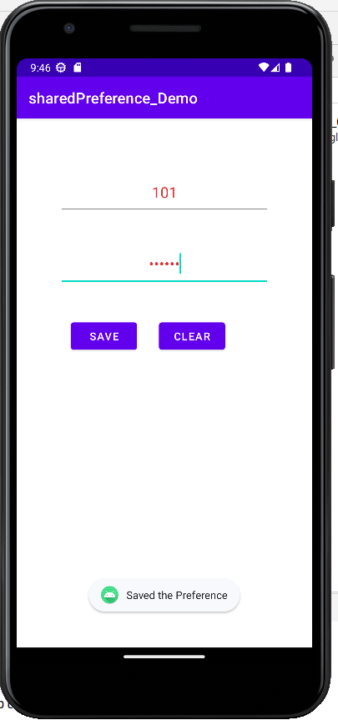

XML CODE:

<?xml version="1.0" encoding="utf-8"?>   
<androidx.constraintlayout.widget.ConstraintLayout xmlns:android="http://schemas.android.com/apk/res/android"   
    xmlns:app="http://schemas.android.com/apk/res-auto"   
    xmlns:tools="http://schemas.android.com/tools"   
    android:layout_width="match_parent"   
    android:layout_height="match_parent"   
    tools:context=".MainActivity">   
   
    <EditText   
        android:id="@+id/txtid"   
        android:layout_width="0dp"   
        android:layout_height="0dp"   
        android:layout_marginStart="16dp"   
        android:layout_marginTop="116dp"   
        android:layout_marginEnd="16dp"   
        android:layout_marginBottom="46dp"   
        android:ems="10"   
        android:gravity="center"   
        android:hint="Enter ID"   
        android:inputType="textPersonName"   
        app:layout_constraintBottom_toTopOf="@+id/txtpass"   
        app:layout_constraintEnd_toEndOf="parent"   
        app:layout_constraintStart_toStartOf="parent"   
        app:layout_constraintTop_toTopOf="parent" />   
   
    <EditText   
        android:id="@+id/txtpass"   
        android:layout_width="0dp"   
        android:layout_height="0dp"   
        android:layout_marginStart="16dp"   
        android:layout_marginEnd="16dp"   
        android:layout_marginBottom="89dp"   
        android:ems="10"   
        android:gravity="center"   
        android:hint="Enter password"   
        android:inputType="textPassword"   
        app:layout_constraintBottom_toTopOf="@+id/btnsave"   
        app:layout_constraintEnd_toEndOf="parent"   
        app:layout_constraintStart_toStartOf="parent"   
        app:layout_constraintTop_toBottomOf="@+id/txtid" />   
   
    <Button   
        android:id="@+id/btnclear"   
        android:layout_width="0dp"   
        android:layout_height="65dp"   
        android:layout_marginEnd="46dp"   
        android:text="clear"   
        app:layout_constraintBaseline_toBaselineOf="@+id/btnsave"   
        app:layout_constraintEnd_toEndOf="parent"   
        app:layout_constraintStart_toEndOf="@+id/btnsave" />   
   
    <Button   
        android:id="@+id/btnsave"   
        android:layout_width="0dp"   
        android:layout_height="0dp"   
        android:layout_marginStart="33dp"   
        android:layout_marginEnd="54dp"   
        android:layout_marginBottom="299dp"   
        android:text="save"   
        app:layout_constraintBottom_toBottomOf="parent"   
        app:layout_constraintEnd_toStartOf="@+id/btnclear"   
        app:layout_constraintStart_toStartOf="parent"   
        app:layout_constraintTop_toBottomOf="@+id/txtpass" />   
</androidx.constraintlayout.widget.ConstraintLayout>

KOTLIN CODE:

package com.example.shared_preference   
   
import androidx.appcompat.app.AppCompatActivity   
import android.os.Bundle   
import android.widget.Button   
import android.widget.EditText   
import android.widget.Toast   
   
class MainActivity : AppCompatActivity() {   
    override fun onCreate(savedInstanceState: Bundle?) {   
        super.onCreate(savedInstanceState)   
        setContentView(R.layout.*activity_main*)   
   
        var etid: EditText = findViewById(R.id.*txtid*)   
        var etps: EditText = findViewById(R.id.*txtpass*)   
        var bnsave: Button = findViewById(R.id.*btnsave*)   
        var bnclr: Button = findViewById(R.id.*btnclear*)   
   
        try {   
            var etunm1: EditText = findViewById(R.id.*txtid*)   
            var etpw1: EditText = findViewById(R.id.*txtpass*)   
            val sharedPreferences = getSharedPreferences("FirstSharedPreferences", *MODE_PRIVATE*)   
            val stringval: String? = sharedPreferences.getString("name", null)   
            val stringval1: String? = sharedPreferences.getString("pw", null)   
            etunm1.setText(stringval)   
            etpw1.setText(stringval1)   
        }   
        catch (e: Exception) {   
            Toast.makeText(this, e.toString(), Toast.*LENGTH_SHORT*).show()   
        }   
   
        bnsave.setOnClickListener **{**   
var etunm: EditText = findViewById(R.id.*txtid*)   
            var etpw: EditText = findViewById(R.id.*txtpass*)   
            var sharedPreferences = getSharedPreferences("FirstSharedPreferences", *MODE_PRIVATE*)   
   
            val editor = sharedPreferences.edit()   
            editor.*apply* **{**   
putString("name", etunm.*text*.toString())   
                putString("pw", etpw.*text*.toString())   
            **}**.apply()   
            Toast.makeText(this, "Saved the Preference", Toast.*LENGTH_SHORT*).show()   
        **}**   
bnclr.setOnClickListener **{**   
val preferences = getSharedPreferences("FirstSharedPreferences", 0)   
            preferences.edit().remove("name").commit()   
            preferences.edit().remove("pw").commit()   
            etid.*text*.clear()   
            etps.*text*.clear()   
        **}**   
}   
}

OUTPUT:



1. Design the Simple GUI using proper Layout also set the background color using Drawable Resource File.

   

1ST XML CODE:

<?xml version="1.0" encoding="utf-8"?>   
<LinearLayout xmlns:android="http://schemas.android.com/apk/res/android"   
    xmlns:app="http://schemas.android.com/apk/res-auto"   
    xmlns:tools="http://schemas.android.com/tools"   
    android:layout_width="match_parent"   
    android:layout_height="match_parent"   
    android:background="#52EFE0"   
    android:orientation="vertical"   
    tools:context=".MainActivity">   
   
   
    <ImageView   
        android:id="@+id/imageView"   
        android:layout_width="200dp"   
        android:layout_height="200dp"   
        android:layout_marginLeft="100dp"   
        android:layout_marginTop="50dp"   
        android:background="#2EEFDD"   
        android:src="@drawable/charusat"/>   
   
    <TableLayout   
        android:layout_width="match_parent"   
        android:layout_height="wrap_content">   
        <TableRow>   
            <TextView   
                android:layout_marginTop="50dp"   
                android:layout_width="match_parent"   
                android:layout_height="wrap_content"   
                android:text="COURSE : "   
                android:textStyle="bold"   
                android:textSize="30dp">   
            </TextView>   
        </TableRow>   
        <RadioGroup>   
            <RadioButton   
                android:layout_width="match_parent"   
                android:layout_height="wrap_content"   
                android:text="JAVA"   
                android:layout_marginLeft="50dp"   
                android:layout_marginTop="10dp"   
                android:textStyle="bold">   
            </RadioButton>   
   
            <RadioButton   
                android:layout_width="match_parent"   
                android:layout_height="wrap_content"   
                android:text="ANDROID"   
                android:layout_marginLeft="50dp"   
                android:textStyle="bold">   
            </RadioButton>   
        </RadioGroup>   
    </TableLayout>   
    <EditText   
        android:layout_width="match_parent"   
        android:layout_height="wrap_content"   
        android:hint="USER ID"   
        android:gravity="center"   
        android:layout_marginTop="30dp">   
    </EditText>   
    <EditText   
        android:layout_width="match_parent"   
        android:layout_height="wrap_content"   
        android:hint="PASSWORD"   
        android:gravity="center"   
        android:inputType="textPassword">   
    </EditText>   
   
    <Button   
        android:id="@+id/btn"   
        android:layout_width="match_parent"   
        android:layout_height="wrap_content"   
        android:layout_marginLeft="10dp"   
        android:layout_marginTop="50dp"   
        android:layout_marginRight="10dp"   
        android:backgroundTint="@color/grey"   
        android:text="SUBMIT"   
        android:textSize="20dp"   
        android:textStyle="bold"></Button>   
</LinearLayout>

1ST OUTPUT:



2ND XML CODE:

<?xml version="1.0" encoding="utf-8"?>   
<LinearLayout   
    xmlns:android="http://schemas.android.com/apk/res/android"   
    xmlns:tools="http://schemas.android.com/tools"   
    xmlns:app="http://schemas.android.com/apk/res-auto"   
    android:layout_width="match_parent"   
    android:layout_height="match_parent"   
    android:orientation="vertical"   
    tools:context=".MainActivity">   
   
    <Button   
        android:layout_width="match_parent"   
        android:layout_height="wrap_content"   
        android:backgroundTint="#837F7F"   
        android:text="Button1">   
    </Button>   
    <Button   
        android:layout_width="match_parent"   
        android:layout_height="wrap_content"   
        android:layout_marginTop="10dp"   
        android:backgroundTint="#837F7F"   
        android:text="Button2">   
    </Button>   
    <Button   
        android:layout_width="match_parent"   
        android:layout_height="wrap_content"   
        android:layout_marginTop="10dp"   
        android:backgroundTint="#837F7F"   
        android:text="Button3">   
    </Button>   
   
    <LinearLayout   
        android:layout_width="match_parent"   
        android:layout_height="match_parent"   
        android:orientation="horizontal">   
   
        <Button   
            android:layout_width="wrap_content"   
            android:layout_height="match_parent"   
            android:layout_marginRight="20dp"   
            android:backgroundTint="#837F7F"   
            android:layout_marginLeft="20dp"   
            android:layout_weight="1"   
            android:text="Button4"></Button>   
   
        <Button   
            android:layout_width="wrap_content"   
            android:layout_height="match_parent"   
            android:layout_marginRight="20dp"   
            android:layout_weight="1"   
            android:backgroundTint="#837F7F"   
            android:text="Button5"></Button>   
   
        <Button   
            android:layout_width="wrap_content"   
            android:layout_height="match_parent"   
            android:layout_marginRight="20dp"   
            android:layout_weight="1"   
            android:backgroundTint="#837F7F"   
            android:text="Button6"></Button>   
    </LinearLayout>   
</LinearLayout>

2ND OUTPUT:



1. Create following GUI using Table Layout and add the product in the SQLite Database



XML CODE:

<?xml version="1.0" encoding="utf-8"?>   
<androidx.constraintlayout.widget.ConstraintLayout xmlns:android="http://schemas.android.com/apk/res/android"   
    xmlns:app="http://schemas.android.com/apk/res-auto"   
    xmlns:tools="http://schemas.android.com/tools"   
    android:layout_width="match_parent"   
    android:layout_height="match_parent"   
    android:background="#E1DCB2"   
    tools:context=".MainActivity">   
   
    <LinearLayout   
        android:layout_width="match_parent"   
        android:layout_height="wrap_content"   
        android:orientation="vertical"   
        tools:ignore="MissingConstraints">   
   
        <TextView   
            android:layout_width="match_parent"   
            android:layout_height="wrap_content"   
            android:layout_marginTop="10dp"   
            android:layout_marginBottom="10dp"   
            android:gravity="center"   
            android:text="NEW PRODUCT FORM"   
            android:textColor="@color/black"   
            android:textSize="34dp"   
            android:textStyle="bold"></TextView>   
   
        <TableLayout   
            android:layout_width="match_parent"   
            android:layout_height="wrap_content"   
            android:padding="10dp">   
   
            <TableRow>   
   
                <TextView   
                    android:layout_width="match_parent"   
                    android:layout_height="wrap_content"   
                    android:layout_marginTop="10dp"   
                    android:layout_marginBottom="10dp"   
                    android:text="Product Code:"   
                    android:textColor="@color/black"   
                    android:textSize="25dp"></TextView>   
   
                <EditText   
                    android:id="@+id/pid"   
                    android:layout_width="157dp"   
                    android:layout_height="wrap_content"   
                    android:layout_marginLeft="50dp"   
                    android:layout_marginTop="10dp"   
                    android:layout_marginBottom="10dp"   
                    android:textColor="@color/black"   
                    android:textSize="25dp"></EditText>   
            </TableRow>   
   
            <TableRow>   
   
                <TextView   
                    android:layout_width="match_parent"   
                    android:layout_height="wrap_content"   
                    android:layout_marginTop="10dp"   
                    android:layout_marginBottom="10dp"   
                    android:text="Product Name:"   
                    android:textColor="@color/black"   
                    android:textSize="25dp"></TextView>   
   
                <EditText   
                    android:id="@+id/pname"   
                    android:layout_width="157dp"   
                    android:layout_height="wrap_content"   
                    android:layout_marginLeft="50dp"   
                    android:layout_marginTop="10dp"   
                    android:layout_marginBottom="10dp"   
                    android:textColor="@color/black"   
                    android:textSize="25dp"></EditText>   
            </TableRow>   
   
            <TableRow>   
   
                <TextView   
                    android:layout_width="match_parent"   
                    android:layout_height="wrap_content"   
                    android:layout_marginTop="10dp"   
                    android:layout_marginBottom="10dp"   
                    android:text="Product Price:"   
                    android:textColor="@color/black"   
                    android:textSize="25dp"></TextView>   
   
                <EditText   
                    android:id="@+id/pprice"   
                    android:layout_width="157dp"   
                    android:layout_height="wrap_content"   
                    android:layout_marginLeft="50dp"   
                    android:layout_marginTop="10dp"   
                    android:layout_marginBottom="10dp"   
                    android:textColor="@color/black"   
                    android:textSize="25dp"></EditText>   
            </TableRow>   
   
            <TableRow   
                android:layout_marginTop="20dp"   
                android:padding="10dp">   
   
                <Button   
                    android:id="@+id/btnap"   
                    android:layout_width="match_parent"   
                    android:layout_height="wrap_content"   
                    android:layout_marginLeft="5dp"   
                    android:backgroundTint="#958F8F"   
                    android:text="ADD PRODUCT"   
                    android:textColor="@color/black"></Button>   
   
                <Button   
                    android:id="@+id/btncl"   
                    android:layout_width="match_parent"   
                    android:layout_height="wrap_content"   
                    android:layout_marginLeft="20dp"   
                    android:backgroundTint="#958F8F"   
                    android:text="CANCEL"   
                    android:textColor="@color/black"></Button>   
            </TableRow>   
        </TableLayout>   
    </LinearLayout>   
</androidx.constraintlayout.widget.ConstraintLayout>

DATABASE CLASS CODE:

package com.example.tablelayout   
   
import android.content.Context   
import android.database.sqlite.SQLiteDatabase   
import android.database.sqlite.SQLiteOpenHelper   
   
class DBHelper(context : Context) : SQLiteOpenHelper(context,"productdb",null,1){   
    override fun onCreate(p0: SQLiteDatabase?) {   
        val create_table = "CREATE TABLE PRODUCTINFO(PCODE INTEGER PRIMARY KEY, PNAME TEXT, PPRICE INTEGER);"   
        p0?.execSQL(create_table)   
    }   
   
    override fun onUpgrade(p0: SQLiteDatabase?, p1: Int, p2: Int) {   
        p0?.execSQL("DROP TABLE IF EXISTS PRODUCTINFO")   
        onCreate(p0)   
    }   
}

KOTLIN CODE:

package com.example.tablelayout   
   
import android.content.ContentValues   
import android.content.DialogInterface   
import android.database.Cursor   
import android.database.sqlite.SQLiteDatabase   
import androidx.appcompat.app.AppCompatActivity   
import android.os.Bundle   
import android.widget.Button   
import android.widget.EditText   
import android.widget.TextView   
import android.widget.Toast   
import androidx.appcompat.app.AlertDialog   
import java.util.concurrent.TimeoutException   
   
class MainActivity : AppCompatActivity() {   
    override fun onCreate(savedInstanceState: Bundle?) {   
        super.onCreate(savedInstanceState)   
        setContentView(R.layout.*activity_main*)   
        var helper = DBHelper(*applicationContext*)   
        var db : SQLiteDatabase = helper.*readableDatabase*   
var rs = db.rawQuery("select * from PRODUCTINFO",null)   
   
        var etid : EditText = findViewById(R.id.*pid*)   
        var etnm : EditText = findViewById(R.id.*pname*)   
        var etpr : EditText = findViewById(R.id.*pprice*)   
        var bnap : Button = findViewById(R.id.*btnap*)   
        var bncl : Button = findViewById(R.id.*btncl*)   
   
        bnap.setOnClickListener **{**   
var cv = ContentValues()   
            cv.put("PID",etid.*text*.toString())   
            cv.put("PNAME",etnm.*text*.toString())   
            cv.put("PPRICE",etpr.*text*.toString())   
            db.insert("PRODUCTINFO",null,cv)   
            rs.requery()   
            Toast.makeText(this,"Product Added", Toast.*LENGTH_LONG*).show()   
        **}**   
   
bncl.setOnClickListener**{**   
var dialogBuilder = AlertDialog.Builder(this);   
            dialogBuilder.setTitle("Alert Dialog Example")   
            dialogBuilder.setMessage("Do you want to close it ? ")   
            dialogBuilder.setPositiveButton("OK", DialogInterface.OnClickListener**{**   
dialog,id**->**finish();   
            **}**)   
            dialogBuilder.setNegativeButton("Cancel", DialogInterface.OnClickListener **{**   
dialog, id **->** dialog.cancel();   
            **}**).show();   
        **}**   
}   
   
}

OUTPUT:



1. Write an application of Crud operations using SQLite database.



XML CODE: <?xml version="1.0" encoding="utf-8"?>   
<LinearLayout xmlns:android="http://schemas.android.com/apk/res/android"   
    xmlns:app="http://schemas.android.com/apk/res-auto"   
    xmlns:tools="http://schemas.android.com/tools"   
    android:layout_width="match_parent"   
    android:layout_height="match_parent"   
    android:orientation="vertical"   
    tools:context=".MainActivity">   
    <EditText   
        android:layout_width="match_parent"   
        android:layout_height="wrap_content"   
        android:hint="Enter employee id"   
        android:gravity="center"   
        android:id="@+id/eeid">   
    </EditText>   
    <EditText   
        android:layout_width="match_parent"   
        android:layout_height="wrap_content"   
        android:hint="Enter employee name"   
        android:gravity="center"   
        android:id="@+id/eenm">   
    </EditText>   
    <TableLayout   
        android:layout_width="match_parent"   
        android:layout_height="wrap_content"   
        android:padding="15dp">   
        <TableRow   
            android:layout_width="match_parent"   
            android:layout_height="wrap_content"   
            android:padding="15dp">   
            <Button   
                android:id="@+id/fb"   
                android:layout_height="wrap_content"   
                android:layout_width="match_parent"   
                android:text="first"   
                android:padding="15dp"   
                android:layout_margin="10dp"   
                android:layout_gravity="center"   
                android:gravity="center">   
            </Button>   
            <Button   
                android:id="@+id/lb"   
                android:layout_height="wrap_content"   
                android:layout_width="match_parent"   
                android:text="last"   
                android:padding="15dp"   
                android:layout_margin="10dp"   
                android:layout_gravity="center"   
                android:gravity="center">   
            </Button>   
        </TableRow>   
        <TableRow   
            android:layout_width="match_parent"   
            android:layout_height="wrap_content"   
            android:padding="15dp">   
            <Button   
                android:id="@+id/nb"   
                android:layout_height="wrap_content"   
                android:layout_width="match_parent"   
                android:text="next"   
                android:padding="15dp"   
                android:layout_margin="10dp"   
                android:layout_gravity="center"   
                android:gravity="center">   
            </Button>   
            <Button   
                android:id="@+id/pb"   
                android:layout_height="wrap_content"   
                android:layout_width="match_parent"   
                android:text="previous"   
                android:padding="15dp"   
                android:layout_margin="10dp"   
                android:layout_gravity="center"   
                android:gravity="center">   
            </Button>   
        </TableRow>   
        <TableRow   
            android:layout_width="match_parent"   
            android:layout_height="wrap_content"   
            android:padding="15dp">   
            <Button   
                android:id="@+id/sb"   
                android:layout_height="wrap_content"   
                android:layout_width="match_parent"   
                android:text="save"   
                android:padding="15dp"   
                android:layout_margin="10dp"   
                android:layout_gravity="center"   
                android:gravity="center">   
            </Button>   
            <Button   
                android:id="@+id/ub"   
                android:layout_height="wrap_content"   
                android:layout_width="match_parent"   
                android:text="update"   
                android:padding="15dp"   
                android:layout_margin="10dp"   
                android:layout_gravity="center"   
                android:gravity="center">   
            </Button>   
        </TableRow>   
        <TableRow   
            android:layout_width="match_parent"   
            android:layout_height="wrap_content"   
            android:padding="15dp">   
            <Button   
                android:id="@+id/db"   
                android:layout_height="wrap_content"   
                android:layout_width="match_parent"   
                android:text="delete"   
                android:padding="15dp"   
                android:layout_margin="10dp"   
                android:layout_gravity="center"   
                android:gravity="center">   
            </Button>   
            <Button   
                android:id="@+id/sdb"   
                android:layout_height="wrap_content"   
                android:layout_width="match_parent"   
                android:text="show data"   
                android:padding="15dp"   
                android:layout_margin="10dp"   
                android:layout_gravity="center"   
                android:gravity="center">   
            </Button>   
        </TableRow>   
    </TableLayout>   
   
    <TextView   
        android:id="@+id/textview"   
        android:layout_width="match_parent"   
        android:layout_height="100dp"></TextView>   
</LinearLayout>

KOTLIN CODE:

package com.example.employee_layout   
   
import android.content.ContentValues   
import android.database.Cursor   
import android.database.sqlite.SQLiteDatabase   
import android.database.sqlite.SQLiteOpenHelper   
import androidx.appcompat.app.AppCompatActivity   
import android.os.Bundle   
import android.widget.Button   
import android.widget.EditText   
import android.widget.TextView   
import android.widget.Toast   
   
class MainActivity : AppCompatActivity() {   
    override fun onCreate(savedInstanceState: Bundle?) {   
        super.onCreate(savedInstanceState)   
        setContentView(R.layout.*activity_main*)   
        var helper = DbHelper(*applicationContext*)   
        var db : SQLiteDatabase = helper.*readableDatabase*   
var rs = db.rawQuery("select * from EMPLOYEE",null)   
   
        var etid : EditText = findViewById(R.id.*eeid*)   
        var etnm : EditText = findViewById(R.id.*eenm*)   
        var etvd : TextView = findViewById(R.id.*textview*)   
        var bfirst : Button = findViewById(R.id.*fb*)   
        var blast : Button = findViewById(R.id.*lb*)   
        var bsave : Button = findViewById(R.id.*sb*)   
        var bdelete : Button = findViewById(R.id.*db*)   
        var bnext : Button = findViewById(R.id.*nb*)   
        var bprev : Button = findViewById(R.id.*pb*)   
        var bupdate : Button = findViewById(R.id.*ub*)   
        var bshowdata : Button = findViewById(R.id.*sdb*)   
   
        bsave.setOnClickListener **{**   
var cv = ContentValues()   
            cv.put("EID",etid.*text*.toString())   
            cv.put("ENAME",etnm.*text*.toString())   
            db.insert("EMPLOYEE",null,cv)   
            rs.requery()   
            Toast.makeText(this,"Insert Successfull",Toast.*LENGTH_LONG*).show()   
        **}**   
   
bfirst.setOnClickListener **{**   
if(rs.moveToFirst()){   
                etid.setText(rs.getString(0))   
                etnm.setText(rs.getString(1))   
            }   
        **}**   
   
blast.setOnClickListener **{**   
if(rs.moveToLast()){   
                etid.setText(rs.getString(0))   
                etnm.setText(rs.getString(1))   
            }   
        **}**   
   
bnext.setOnClickListener **{**   
if(rs.moveToNext()){   
                etid.setText(rs.getString(0))   
                etnm.setText(rs.getString(1))   
            }   
            else if (rs.moveToFirst()){   
                etid.setText(rs.getString(0))   
                etnm.setText(rs.getString(1))   
            }   
        **}**   
   
bprev.setOnClickListener **{**   
if(rs.moveToPrevious()){   
                etid.setText(rs.getString(0))   
                etnm.setText(rs.getString(1))   
            }   
            else if (rs.moveToLast()){   
                etid.setText(rs.getString(0))   
                etnm.setText(rs.getString(1))   
            }   
        **}**   
   
bupdate.setOnClickListener **{**   
var cv = ContentValues()   
            cv.put("EID",etid.*text*.toString())   
            cv.put("ENAME",etnm.*text*.toString())   
            db.update("EMPLOYEE",cv,"EID=?", *arrayOf*(etid.*text*.toString()))   
            rs.requery()   
            if(rs.moveToFirst()){   
                etid.setText(rs.getString(0))   
                etnm.setText(rs.getString(1))   
            }   
            Toast.makeText(this, "Record Updated",Toast.*LENGTH_LONG*).show()   
        **}**   
   
bdelete.setOnClickListener **{**   
db.delete("EMPLOYEE","EID=?", *arrayOf*(rs.getString(0)))   
            rs.requery()   
            Toast.makeText(this,"Record Deleted",Toast.*LENGTH_LONG*).show()   
            if(rs.moveToFirst()){   
                etid.setText(rs.getString(0))   
                etnm.setText(rs.getString(1))   
            }   
        **}**   
   
bshowdata.setOnClickListener **{**   
var rs : Cursor = db.rawQuery("SELECT * FROM EMPLOYEE",null)   
            if(etvd.*text* == ""){   
                while (rs.moveToNext()){   
                    etvd.setText(etvd.*text*.toString() + "\n"+ rs.getString(0) + "\t"+ rs.getString(1))   
                }   
            }   
            else{   
                etvd.*text* = ""   
                while (rs.moveToNext()){   
                    etvd.setText(etvd.*text*.toString() + "\n"+ rs.getString(0) + "\t"+ rs.getString(1))   
                }   
            }   
        **}**   
}   
}

Database Class Code:

package com.example.employee_layout   
   
import android.content.Context   
import android.database.sqlite.SQLiteDatabase   
import android.database.sqlite.SQLiteOpenHelper   
   
class DbHelper(context : Context) : SQLiteOpenHelper(context,"Employeedb",null,1){   
    override fun onCreate(db: SQLiteDatabase?) {   
        val create_table = "CREATE TABLE EMPLOYEE(EID INTEGER PRIMARY KEY, ENAME TEXT);"   
        db?.execSQL(create_table)   
    }   
    override fun onUpgrade(db: SQLiteDatabase?, oldVersion: Int, newVersion: Int) {   
        db?.execSQL("DROP TABLE IF EXISTS EMPLOYEE")   
        onCreate(db)   
    }   
}

OUTPUT: